Use case: Georeferencing
The use case deals with the exchange of geometric IFC data that needs to be related to a real position and orientation on the Earth as precisely as possible. For example, this plays a role while setting up a project, coordinating with other disciplines, or during collision control. A formalization of the scenario is presented below:
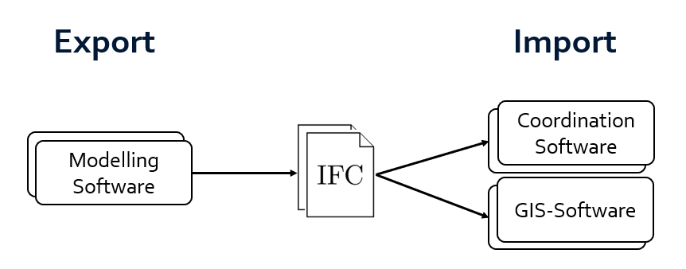
As depicted, the potential participants are:
- Modelling software (for any AEC object, buildings and infrastructure alike)
- Coordination software (that would for example use the data for collision check)
- GIS software (that would contextualize IFC data with GIS data)
In general, any software that deals with how digital IFC geometries relate to the Earth is welcome to participate. Also: any software can participate for both export and import.

IFC concepts and entities
In scope – must have:
- Basic project backbone (IfcProject, IfcUnitAssignment and IfcGeometricRepresentationContext)
- Basic spatial and object structure (IfcSite and IfcBuildingElementProxy)
- Georeferencing metadata (IfcProjectedCRS, IfcMapConversion and IfcRigidOperation)
- Tessellated geometric representation (IfcProductDefinitionShape, IfcShapeModel and IfcTriangulatedFaceSet)
- Local placement (IfcLocalPlacement)
- IFC 4.3.2.0 or IFC 4.0.2.1
In scope – nice to have:
- Well-known text (WKT) definition of a coordinate reference system (IfcWellKnownText)
- Geodetic transformations between different coordinate reference systems (import)
- Georeferencing metadata (IfcGeodeticCRS, IfcMapConversionScaled)
- Both IFC 4.0.2.1 and IFC4.3.2.0, as well as IFC 2.3.0.1
Out of scope:
- Complex IFC geometries (e.g. IfcAdvancedBrep or IfcExtrudedAreaSolid)
- Linear placement (IfcLinearPlacement)
- Complex spatial and functional structure (IfcSpatialElement and IfcGroup)

Use case: Alignment exchange
The use case deals with the exchange of geometric and semantic alignment information. This includes the horizontal as well as vertical alignments. We are striving for an exchange of full design logic, potentially reference geometry. A formalization of the scenario is presented below:
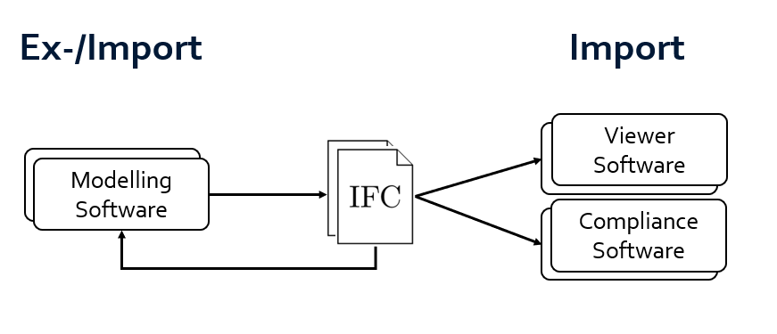
As depicted, the potential participants are:
- Modelling software (for alignments; roads, railways, piping, cables, …)
- Viewer software (that visualizes the data, e.g. with other IFC data)
- Compliance software (that checks the alignment against normative standards)
In general, any software that deals with alignments is welcome to participate. Also: any software can participate for both export and import – which we encourage modelers to do!

IFC concepts and entities
In scope – must have:
- Basic project backbone (IfcProject, IfcUnitAssignment and IfcGeometricRepresentationContext)
- Basic spatial and object structure (IfcSite and IfcAlignment)
- Alignment semantic structure (IfcRelNests, IfcAlignment, IfcLinearElement)
- IFC 4.3.2.0
In scope – nice to have:
- Georeferencing use case
- Cant alignment (IfcAlignmentCant)
- Alignment parametric geometric representation (IfcCompositeCurve, IfcCurveSegment)
- Alignment tessellated geometric representation (IfcPolyline)
- All transition curves (IfcSpiral)
- Stationing & stationing jumps (IfcReferent, IfcLinearPlacement)
Out of scope:
- Volumetric IFC geometries (IfcSolidModel)
- Complex spatial and functional structure (IfcSpatialElement and IfcGroup)
- Digital terrain models (IfcGeographicElement)

